# DAD 220 Module Four Major Activity Database Documentation Template

Complete these steps as you work through the directions for this activity. Replace the bracketed text with your screenshots and brief explanations of the work they capture. Each screenshot and its explanation should be sized to approximately one quarter of the page, with the description written below the screenshot. Follow these rules for each of the prompts and questions below. Review the example document for assistance.

**Follow Steps 1 through 4 from the Module Three Major Activity *only* to generate tables for this assignment.**

1. Import the data from each file into tables.
   1. Use the import utility of your database program to load the data from each file into the table of the same name. You’ll perform this step three times, once for each table.
   2. Provide the SQL commands you ran against MySQL to complete this successfully in your answer.







LOAD DATA INFILE ‘/home/codio/workspace/customers.csv’ INTO TABLE Customers FIELDS TERMINATED BY ‘,’ ENCLOSED BY ‘”’ LINES TERMINATED BY ‘\n’;

LOAD DATA INFILE ‘/home/codio/workspace/orders.csv’ INTO TABLE Orders FIELDS TERMINATED BY ‘,’ ENCLOSED BY ‘”’ LINES TERMINATED BY ‘\n’;

LOAD DATA INFILE ‘/home/codio/workspace/rma.csv’ INTO TABLE RMA FIELDS TERMINATED BY ‘,’ ENCLOSED BY ‘”’ LINES TERMINATED BY ‘\n’;

1. Write basic queries against imported tables to organize and analyze targeted data.

For each query, include a screenshot of the query and its output. You should also include a 1- to 3-sentence description of the output.

* 1. Write an SQL query that returns the count of orders for customers located only in the city of Framingham, Massachusetts.
     1. How many records were returned?

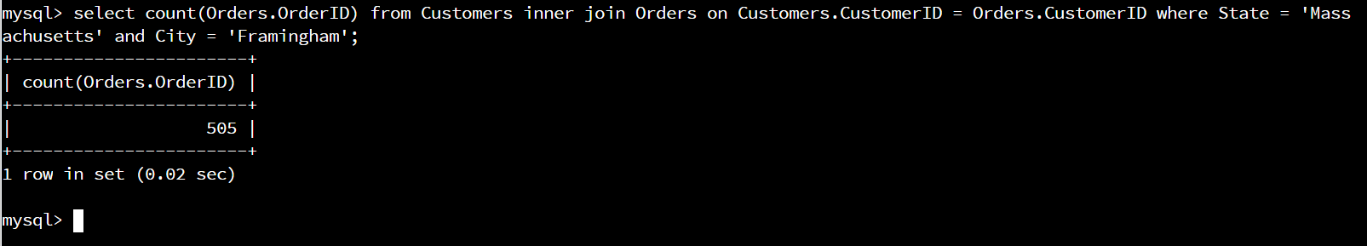Select count(Orders.OrdersID) from Customers inner join Orders on Customers.CustomerID = Orders.CustomerID where State = ’Massachusetts’ and City = ’Framingham’;

Preforms a inner join between Customers and Orders when the customerID matches and outputs the count of the rows that have Massachusetts as the state and Framingham as the city.

There were 505 records returned.

* 1. Write an SQL query to select all of the customers located in the state of Massachusetts.
     1. Use a WHERE clause to limit the number of records in the Customers table to only those that are located in Massachusetts.
     2. Record an answer to the following question: How many records were returned?

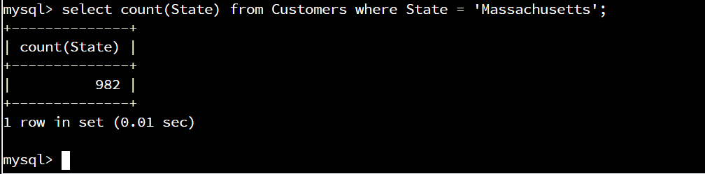Select count(State) from Customers where State = ’Massachusetts’;

Outputs the count of records in Customers that have the state as Massachusetts.

There where 982 records returned.

* 1. Write an SQL query to insert four new records into the Orders and Customers tables using the following data:
     1. Customers Table

| **CustomerID** | **FirstName** | **Lastname** | **StreetAddress** | **City** | **State** | **ZipCode** | **Telephone** |
| --- | --- | --- | --- | --- | --- | --- | --- |
| 100004 | Luke | Skywalker | 17 Maiden Lane | New York | NY | 10222 | 212-555-1234 |
| 100005 | Winston | Smith | 128 Sycamore Street | Greensboro | NC | 27401 | 919-555-6623 |
| 100006 | MaryAnne | Jenkins | 2 Coconut Way | Jupiter | FL | 33458 | 321-555-8907 |
| 100007 | Janet | Williams | 58 Redondo Beach Blvd | Torrence | CA | 90501 | 310-555-5678 |

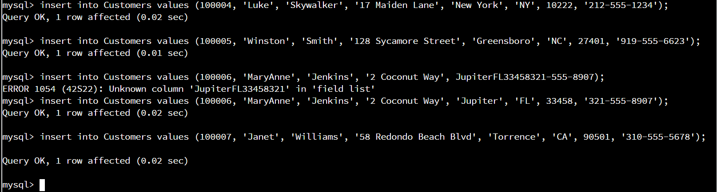

Insert into Customers values (100004, ‘Luke’, ‘Skywalker’, ‘17 Maiden Lane’, ‘New York’, ‘NY’, 10222, ‘212-555-1234');

Insert into Customers values (100005, ‘Winston’, ‘Smith’, ‘128 Sycamore Street’, ‘Greensboro’, ‘NC’, 27401, ‘919-555-6623');

Insert into Customers values (100006, ‘MaryAnne’, ‘Jenkins’, ‘2 Coconut Way’, ‘Jupiter’, ‘FL’, 33458, ‘312-555-8907');

Insert into Customers values (100007, ‘Janet’, ‘Williams’, ‘58 Redondo Beach Blvd’, ‘Torrence’, ‘CA’, 90501, ‘310-555-5678');

* + 1. Orders Table

| **OrderID** | **CustomerID** | **SKU** | **Description** |
| --- | --- | --- | --- |
| 1204305 | 100004 | ADV-24-10C | Advanced Switch 10GigE Copper 24 port |
| 1204306 | 100005 | ADV-48-10F | Advanced Switch 10 GigE Copper/Fiber 44 port copper 4 port fiber |
| 1204307 | 100006 | ENT-24-10F | Enterprise Switch 10GigE SFP+ 24 Port |
| 1204308 | 100007 | ENT-48-10F | Enterprise Switch 10GigE SFP+ 48 port |

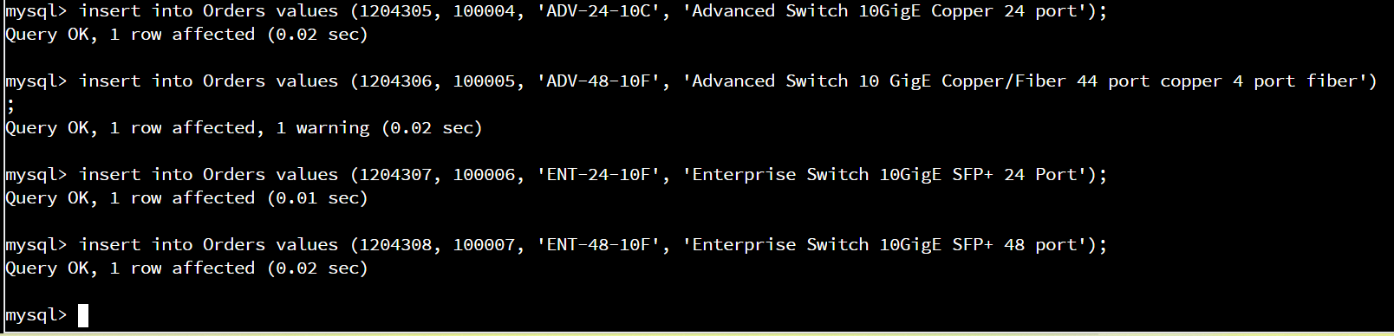

Insert into Orders values (1204305, 100004, ‘ADV-24-10C', ‘Advanced Switch 10GigE Copper 24 port’);

Insert into Orders values (1204306, 100005, ‘ADV-48-10F', ‘Advanced Switch 10 GigE Copper/Fiber 44 port copper 4 port fiber’);

Insert into Orders values (1204307, 100006, ‘ENT-24-10F', ‘Enterprise Switch 10GigE SFP+ 24 Port’);

Insert into Orders values (1204308, 100007, ‘ENT-48-10F', ‘Enterprise Switch 10GigE SFP+ 48 Port’);

* 1. In the Customers table, perform a query to count all records where the city is Woonsocket, Rhode Island.
     1. How many records are in the customers table where the field “city” equals “Woonsocket”?

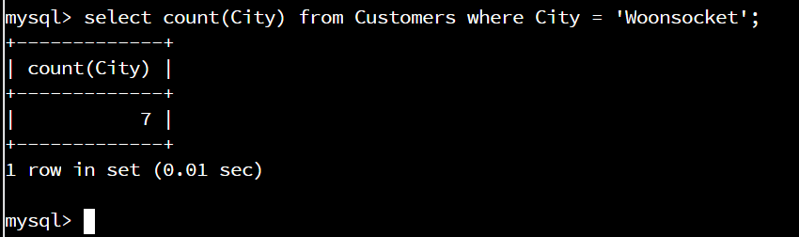Select count(City) from Customers where City = ’Woonsocket’;

Outputs the count of Customers where the city is Woonsocket.

There were 7 records returned.

* 1. In the RMA database, update a customer’s records.
     1. Write an SQL statement to select the current fields of **status** and **step** for the record in the **rma**table with an **orderid**value of “5175.”
        1. What are the current status and step?

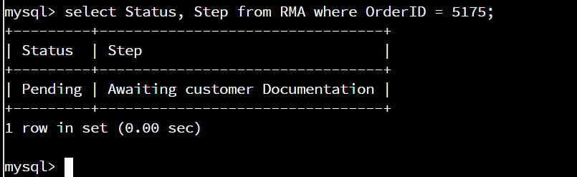Select Status, Step from RMA where OrderID = 5175;

Outputs the Status and Step of RMA where the OrderID is 5175.

Status = Pending and Step = Awaiting customer Documentation

* + 1. Write an SQL statement to update the**status** and **step**for the **OrderID**, 5175 to **status**= “Complete” and **step**= “Credit Customer Account.”
       1. What are the updated **status**and **step**values for this record? Provide a screenshot of your work.

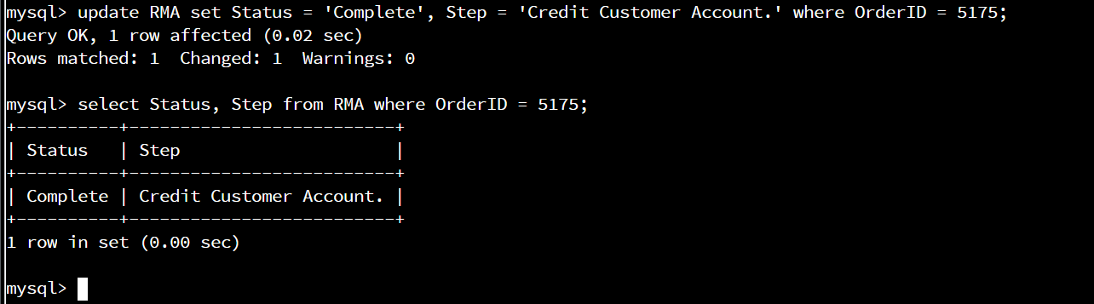

update RMA set Status = ‘Complete’, Step = ‘Credit Customer Account.’ where OrderID = 5175;

select Status, Step from RMA where OrderID = 5175;

Changes and then outputs Status as Complete and Step as Credit Customer Account.

* 1. Delete RMA records.
     1. Write an SQL statement to delete all records with a reason of “Rejected.”
        1. How many records were deleted? Provide a screenshot of your work.

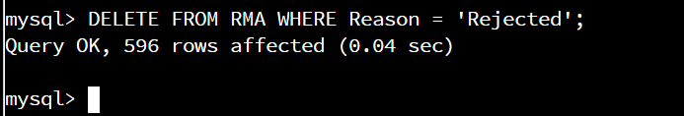Delete from RMA where Reason = ’Rejected’;

Deletes all rows in RMA that have Reason = ‘Rejected’;

There where 596 records deleted.

1. Create an output file of the required query results.

Write an SQL statement to list the contents of the orders table and send the output to a file with a .csv extension.



Select * from Orders into outfile ‘/home/codio/workspace/orders_output_file.csv’ fields terminated by ‘,’ lines terminated by ‘\r\n’;